­­

The New York State ECAC   
*A Whole System Perspective*

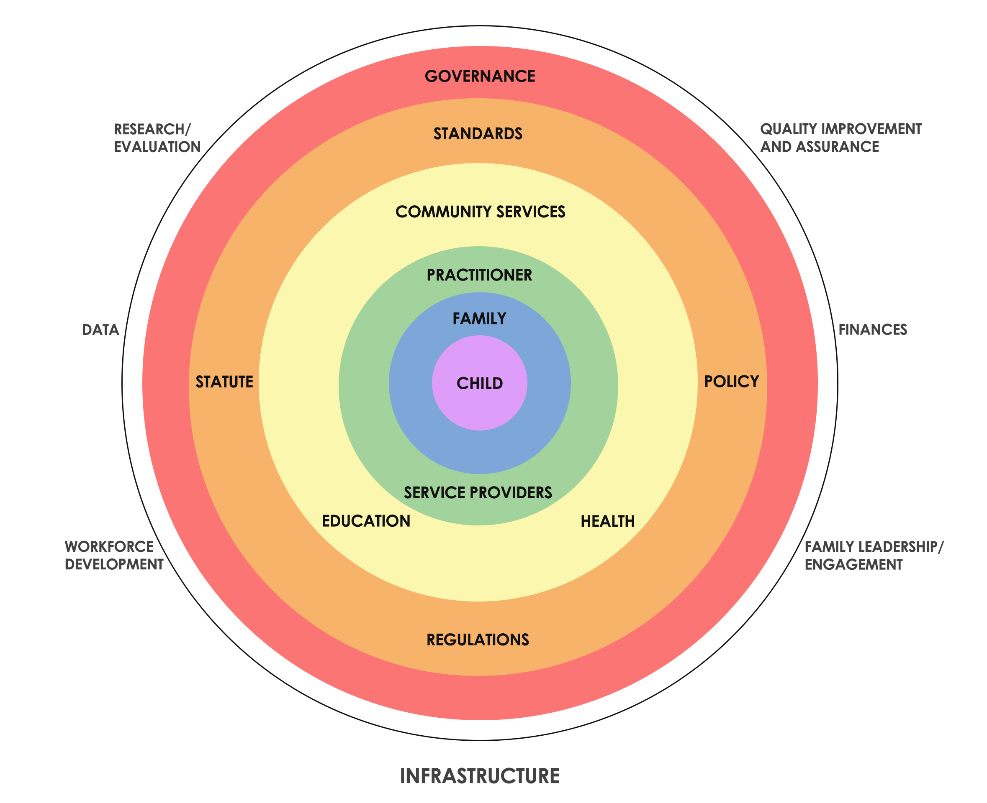

The Steering Committee met on April 24th to design a context for our Strategic Planning efforts.  This graphic emerged as a system-based concept/approach.  Maggie, our Strategic Planning Facilitator, them reviewed and modified the chart to incorporate certain requirements designated by the PDG B-5 grant.  We will use this as a resource for our strategic planning work today and at the Strategic Planning Retreat in August.