Sherry M. Cleary, Co-Chair
New York Early Childhood Professional Development Institute, Executive Director http://www.earlychildhoodnyc.org/
Sherry M. Cleary is the Executive Director of the New York City Early Childhood Professional Development Institute, housed at the City University of New York. Ms. Cleary has worked in the field of early childhood education as a classroom teacher, a program administrator, and as both a faculty member and higher education administrator for more than 35 years. She is the founder of the University of Pittsburgh Institute for Excellence in Early Childhood Education. Currently, she serves as President of the New York State Association of Early Childhood Teacher Educators (NYSAECTE) and on the Board of the National Association of Early Childhood Teacher Educators.

Patricia E. Persell, Co-Chair
New York State Head Start Collaboration Office, Collaboration Director http://www.ccf.ny.gov/HS/index.cfm
Patricia E. Persell is New York State Head Start Collaboration Director, working to ensure that Head Start is included in state programs and policies. She began her career as a nursery school teacher, worked as Education Coordinator for Albany County Head Start and then served as Director of the Bank Street Head Start in New York City. A longtime La Leche League Leader volunteer, she also serves on the Obesity Prevention in Child Care Partnership, a state level steering committee.

Melissa Alexander
NYS Office of Temporary and Disability Assistance, Employment and Income Support Programs
Melissa Alexander works in Employment and Income Support Programs (EISP) at the New York State Office of Temporary and Disability Assistance (OTDA). Melissa’s focus at EISP is on employment-driven programs that support OTDA’s mission to enhance the economic security of low-income individuals and families. She earned a Bachelor’s degree in Social Welfare from the College of Saint Rose, and a Master’s degree in Public Administration from the Rockefeller College of Public Affairs and Policy, where she focused her studies on human resources management and social welfare policy.
Evelyn Blanck
New York Center for Child Development, Associate Executive Director http://www.nyccd.org
Evelyn Blanck is the Associate Executive Director of the New York Center for Child Development and Program Director for the Early Childhood Mental Health Consultation and Treatment Program. She is Co-President of the New York Zero to Three Network and Chair of the New York City Early Childhood Mental Health Strategic Work Group, an advisory committee to the New York City Department of Health and Mental Hygiene. Evelyn has focused much of her work on the integration of mental health in education, primary care and all child serving systems. She has a New York City mayoral appointment to the Community Services Board Subcommittee on Mental Retardation and Developmental Disabilities.

Kate Breslin
Schuyler Center for Analysis and Advocacy, President & CEO http://www.scaany.org
Kate Breslin is the President & CEO of the Schuyler Center for Analysis and Advocacy, a statewide nonprofit organization working to shape policies to improve health and human services in New York State. Kate has spent her career working for policy solutions that improve the lives of low-income and vulnerable people. She serves on the Capital Region Advisory Committee for the Health Insurance Exchange; Medicaid Evidence-Based Benefit Review Workgroup; and Behavioral Health Services Workgroup. She helps lead several statewide coalitions, including Winning Beginning NY; Medicaid Matters New York; Health Care for All New York; and the New York State Coalition for Adult Home Reform.

Meredith Chimento
Early Care and Learning Council, Executive Director http://www.earlycareandlearning.org
Meredith Chimento is the Executive Director of the Early Care and Learning Council (ECLC). Meredith began her career as a Community Education Peace Corps Volunteer in the Dominican Republic, followed by many years at the Capital District YMCA. Prior to ECLC Meredith worked for the United Way of the Greater Capital Region focusing on ways to change community conditions specific to basic needs, education, income and health.

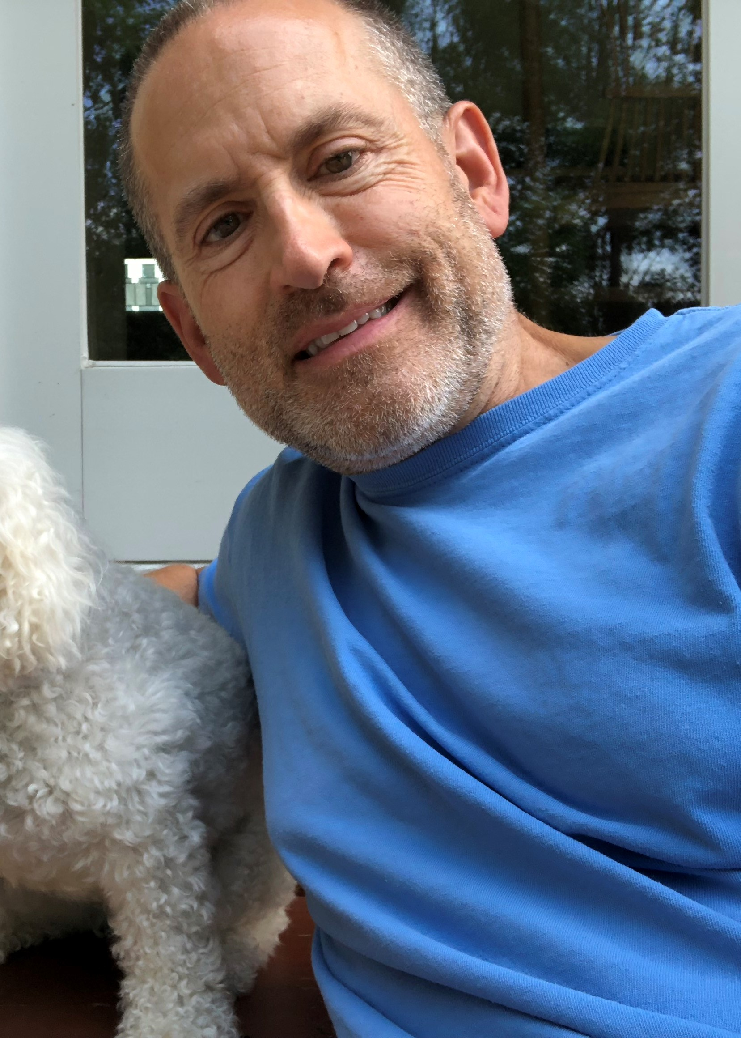Philip Cleary
North Syracuse Central School District, Special Education Teacher http://nscsd.org/webpages/pcleary/
Phil Cleary represents New York State United Teachers (NYSUT). Phil is a career classroom teacher working at the North Syracuse Early Education Program (4410) in North Syracuse. Phil also serves as NYSUT's political action coordinator for education and social justice in Central New York.

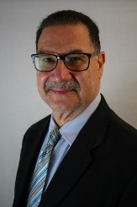
Pedro Cordero
Goddard Riverside Community Center, Director of Child Development Services http://www.goddard.org
Pedro Cordero is currently the Systems Specialist for the Region II Office of Head Start--Training and Technical Assistance Network. His career in early education spans 40 years in multiple positions: Classroom Teacher, Child Development Services Program Director, Operations and Policy work with the Mayor's Office for Children and Families and the NYC Administration for Children Services. In addition, he has served as a Federal Monitor of Head Start grantees and Adjunct Instructor at the City University of New York, Dept of Early Education. With the ECAC, he is the Co-Chair of the Strong Families subcommittee.

Andre Eaton
The Parent-Child Home Program, New York State Regional Coordinator http://www.parent-child.org
Andre Eaton is the Regional Coordinator for The Parent-Child Home Program, a home-based literacy and parenting program for at-risk families. Before joining The Parent-Child Home Program, he worked for Covenant House New York, as Southeastern Regional Director for Jumpstart for Young Children, Inc. and served as Executive Director of Covenant House Georgia. He is currently a candidate for a Masters of Divinity at The Interdenominational Theological Center and works as a student supervisor to those studying social work.

Maggie Evans, C.P.A.
Agri-Business Child Development (ABCD), Executive Director http://www.abcdny.org/
Maggie Evans joined Agri-Business Child Development (ABCD) in 1995 as Director of Finance and became Executive Director in 1999. ABCD serves over 1,500 children annually, with 12 Migrant and Seasonal Head Start centers throughout New York State, a traditional Head Start Program in Seneca County and an Early Head Start Program in Orange County. Maggie began her career in the corporate world, working at both KeyBank and Earst & Young. She is a member of the CEO/Community Partner Affiliate of the National Migrant and Seasonal Head Start Association’s Board of Directors and the New York State Community Services Block Grant Advisory Council.

Melanie Faby
NYS Education Department, Title 1 and Homeless Education

Robert G. Frawley
Early Childhood Policy Consultant
Bob Frawley's work has been directed at building effective systems of supports and services for children and families. This includes working on a variety of research and policy initiatives, including projects addressing such issues as runaway and homeless youth, child abuse and neglect, juvenile justice, prevention programs, and services for children with disabilities. For the last 23 years, he has focused his efforts primarily on issues related to young children and their families. Bob has led many statewide early childhood initiatives. On the ECAC, he Co-chairs the Coordinated and Responsive Systems Focus Area, which is comprised of six work teams. He also co-chairs the Data Development Work Team. Outside of the ECAC, he supports the Adirondack Birth to Three Alliance, which is a project of the Adirondack Foundation.

Jeanne S. Gallbraith
State University of New York College at Geneseo, Visiting Assistant Professor of Inclusive Early Childhood Education
Jeanne S. Galbraith begins a new position as a Visiting Assistant Professor of Inclusive Early Childhood Education in the fall at the State University of New York College at Geneseo (SUNY Geneseo). Prior to this position she was an Assistant Professor and Early Childhood Coordinator at the State University of New York College at Cortland (SUNY Cortland). Dr. Galbraith has worked in the field of early childhood and early childhood special education as a classroom teacher and as a faculty member for over 20 years. Currently, she serves as the President of the New York State Association of Early Childhood Teacher Educators (NYSAECTE).

Timothy Hathaway
Prevent Child Abuse New York, Executive Director http://www.preventchildabuseny.org
Tim Hathaway has served as the Executive Director of Prevent Child Abuse New York since 2014 and in this position he has focused on promoting proven child abuse prevention strategies such as home visiting, community based sex abuse prevention, advocacy and public awareness. Tim is passionate about eliminating racial disparities, promoting best practice standards to prevent child abuse, excellence in non-profit administration and advancing place based, partner-driven solutions. He also believes in the value of professional development and has been a trainer and consultant to early childhood professionals for 25 years. Prior to his work with Prevent Child Abuse New York, Tim was the Executive Director of Prevent Child Abuse in North Dakota and for almost 20 years before that he worked with Head Start programs in a variety of capacities. Very early in his career, he managed and directed early care and learning programs for the YMCA and faith-based communities. In sum, Tim brings nearly 30 years and a great range of experience working with children and families.

Liz Isakson, Ph.D.
Docs for Tots, Executive Director
Dr. Isakson is the Executive Director of Docs for Tots, a non-profit organization that promotes practices, policies, and investments that will enable young children to thrive. Docs for Tots creates linkages between doctors, policymakers, early childhood practitioners, and other stakeholders to ensure that children grow up healthy. Dr. Isakson is a pediatrician and public health practitioner with over 20 years of experience. She has multiple publications published across the systems of early care and education, health, and family economic security. She teaches advocacy to graduate level students at Mt. Sinai School of Public Health. Dr. Isakson trained in general pediatrics at the Children's Hospital of New York where she was Chief Resident. She received her medical degree from the University of Connecticut Medical School.

Mark K. Jasinski
Broome County, Preschool Special Education Program Coordinator
Mark brings over 20 years of experience as an educator and school district administrator. As a certified special education teacher and father of two children with special needs he has a keen understanding of the importance of quality early childhood programming. He serves as a liaison to the New York State Prekindergarten through Grade 3 Administrator’s Association where he served as a Past President. In 2007, he served on the Temporary Task Force on Preschool Special Education and continues to advocate for the inclusion of all students in quality early childhood educational settings.

Ira Katzenstein
Cattaraugus County Project Head Start, Director http://headstartnetwork.com/wordpress/
Ira Katzenstein is Director of Cattaraugus County Project Head Start, which expanded to serve Wyoming County in 1990, and to include Early Head Start in 1998. Eleven years ago, Head Start became the local Success by Six program lead. In his tenure, the program has partnered with many agencies and school districts on projects that include Universal Pre-K programming, Cavity Free Kids, and Early Reading First as well as accreditation of all sites by the National Association for the Education of Young Children. Ira is a member of the Town of Olean planning board and Olean Board of Education. He also serves on the boards of the Cattaraugus County Arts Council, Teacher Resource Center and New York State Head Start Association.
Kristen Kerr
New York State Association for the Education of Young Children, Executive Director http://www.nysaeyc.org
Kristen is the Executive Director of the New York State Association for the Education of Young Children, (NYSAEYC), a membership association for early childhood professionals. She first joined NYSAEYC as Public Policy Coordinator and as a longtime member of the association, brings more than 20 years of experience as an early care and education professional. She represented NYSAEYC as co-convener of the Winning Beginning NY coalition.

Abbe Kovacik
Capital District Child Care Coordinating Council, Inc., Executive Director
Abbe Kovacik is the Executive Director of the Capital District Child Care Coordinating Council, Inc. located in Albany, NY. The Capital District Child Care Council is a non-profit agency focused on improving the quality of early childhood education and after-school programming across the community. Abbe served as faculty at Schenectady County Community College, Fulton Montgomery Community College, and at the College of Saint Rose where she taught courses in early childhood education. Abbe holds a B.S. in Psychology from Messiah College in Grantham, Pennsylvania, and a Master of Education in Educational Psychology from the College of Saint Rose. She is the co-author of Observing and Understanding Child Development: A Child Development Manual published by Delmar Cengage Learning.

Dr. Ralph Marino, Jr.
Hewlett-Woodmere Public Schools, School Superintendent
Dr. Ralph Marino is the Superintendent of Hewlett-Woodmere Public Schools, a District comprised of approximately 3,100 students. Dr. Marino's background in education spans nearly 24 years. He has served as Superintendent of both Horseheads and Hunter-Tannersville School Districts. In addition, Dr. Marino served as the Middle and High School Principal at Hunter-Tannsersville, as well as the Middle School Assistant Principal at the Ravena-Coeymans-Selkirk School District. He also has classroom teaching experience. Currently, Dr. Marino serves on the Governing Board of the American Association of School Administrators. He also is an active member of the National Association for Supervision and Curriculum Development and the New York State Association of School Business Officials.

Lisa Mars
CA Technologies
CA Technologies has offered childcare to employees since 1992. These programs are fully-accredited Montessori Children's Centers located in Islandia as well as several other sites in the United States, the United Kingdom Australia and Hyderabad, India. Young school children around the world accompany their mothers and fathers to CA Technologies offices and it is the only corporation to have onsite Montessori programs that simultaneously are recognized by the Association Montessori International and accredited by the National Association for the Education of Young Children.

Janice M. Molnar, Ph.D.
New York State Office of Children and Family Services, Deputy Commissioner, Division of Child Care Services http://ocfs.ny.gov/main/childcare/
Janice M. Molnar, Ph.D. is Deputy Commissioner of the Division of Child Care Services in the New York State Office of Children and Family Services (OCFS), providing oversight and monitoring of more than 21,000 regulated child care providers and another 47,000 legally-exempt providers in New York State. Trained as a developmental psychologist, her 30-year career includes work in the public and non-profit sectors, concentrating on program and policy issues affecting children, youth, and families.

Jenn O'Connor
Prevent Child Abuse New York, Director of Policy and Advocacy http://http://www.preventchildabuseny.org/
Jenn O’Connor is the Director of Policy and Advocacy for Prevent Child Abuse New York, where she focuses on impacting the root causes of abuse through policy change, thereby strengthening families and the systems that serve them. She also co-chairs Winning Beginning NY and sits on several nonprofit boards. Over the last two decades, Jenn has acquired expertise in maternal and child health, mental health, and early learning. From championing the expansion of health insurance coverage at the National Conference of Insurance Legislators; to creating the mental health program at the National Governors Association; to advocating for a comprehensive home visiting system at the Schuyler Center for Analysis and Advocacy; to leveraging the voices of law enforcement, business, and retired military leaders as NYS Director of Council for a Strong America; she has demonstrated her effectiveness in affecting policy change. Jenn has served as staff for both the Senate Majority (Republican) and the Assembly Majority (Democrat). She has a degree in Creative Writing Arts and a minor in Sociology, as well as a certificate in non-profit management and leadership from Rockefeller College of Public Affairs and Policy. Last but certainly not least Jenn is the former (but still active!) foster parent of a teenage girl and pet parent to Zelda.

Tina Rose-Turriglio
New York State Education Department, Project Coordinator for the Federal Preschool Development Expansion Grant http://http://www.p12.nysed.gov/earlylearning/
Tina Rose-Turriglio is a Project Coordinator for the federal Preschool Development Expansion Grant at the New York State Education Department. Prior to working at NYSED , she worked as a trainer for the
Capital District Child Care Council. Additionally, she has worked at Head Start as an Education
Coordinator and Director and has taught courses in teacher education at the College of St. Rose, Schenectady County Community College and the Community College of Vermont in Bennington. She has an ED in Early Childhood Education from Northcentral University in Arizona.

Mary A. Shaheen
United Way of New York State, Vice President http://www.uwnys.org
Mary A. Shaheen is Vice President of United Way of New York State, serving 40 local United Ways statewide. She first joined UWNYS as Director of the Early Childhood Investment Fund, a state-wide public/private partnership aimed at finding local solutions to early childhood priorities. She chaired the committee that developed criteria for 2-1-1 designated regional call centers and continues to serve on the 2-1-1 New York’s Application Review and Oversight Committee. She is also a member of the Leadership Group for New York State Partners for Children, the USNY Early Childhood Cabinet and
OASAS’ State Epidemiological Outcomes Workgroup. Prior to joining UWNYS, Ms. Shaheen worked for 10 years in local youth programs and as staff member to Assembly Majority Leader James Tallon.

Beth Starks
Teacher Education program at Jamestown Community College, Assistant Professor and the Early Childhood Education Coordinator
Founder and Executive Director of Chautauqua Lake Child Care Center
Beth Starks is an Assistant Professor and the Early Childhood Education Coordinator on the faculty in the Teacher Education program at Jamestown Community College, Founder and Executive Director of Chautauqua Lake Child Care Center, and a Level 3 NYS Early Learning Credentialed Trainer. She recently received Child Care Exchange magazine's Exceptional Emerging Leader award. Beth has her Bachelor's Degree in Elementary Education with an Early Childhood Annotation and her Master's Degree in Curriculum and Instruction. Beth has many years of experience with young children and their families in the public school, in-home child care and center-based child care. She also has over 10 years of experience facilitating professional development for providers, teachers and pre-service educators. Beth also spends time consulting and serves on many local boards, coalitions and committees, including the NYAEYC board, the Winning Beginning steering committee, and the Governor’s Early Childhood Advisory Council. Beth lives in Mayville, NY with her husband and 3 children (Ethan - 14, Aiden - 10, & Ella - 5).

Lauri Strano
Children's Institute, Director of Programs
As the Director of Programs and Services at Children’s Institute, Lauri Strano manages large-scale community-wide collaborations and assessment systems serving young children and youth. Her experience includes working with providers, parents, and policymakers in the context of local, state, and federally funded grants and initiatives. She holds BS degrees from University of Rochester in Psychology and Political Science, and an MS in Elementary Education and NYS certification with specialization in early childhood from Nazareth College. Lauri also has fifteen years of experience in early childhood development programs as an administrator, teacher, and caregiver.

Vanessa Threatte
State University of New York Charter Schools Institute, Executive Deputy Director for Best Practices and Partnerships
Vanessa Threatte serves as Executive Deputy Director for Best Practices and Partnerships at the State University of New York Charter Schools Institute. Ms. Threatte is responsible for highlighting effective models of practice through the documentation and dissemination of existing and/or new evidencebased practices, research, and innovations from the SUNY portfolio of charter schools. Additionally, she is responsible for identifying and maintaining strategic partnerships that support the exchange of good practice and further the effectiveness of the Institute. Ms. Threatte previously served as the Executive Director of the NYS Cradle to Career (C2C) Alliance, a SUNY effort focused on strengthening New York’s education pipeline by improving outcomes for students from birth, through college, and to career. She brings to the Institute her leadership and education experience helping to found a charter school, and her work as a classroom teacher, administrator, and principal, where she worked to ensure the quality of educational experiences for high-risk, high-need, urban populations. Additionally, Ms. Threatte brings her understanding of social, emotional, and mental health needs from her clinical training as an art therapist and her work with children and adults with a variety of special needs. She received her Bachelor of Arts degree from Dartmouth College, a Master of Arts in Art Therapy from the School of the Art Institute of Chicago, and dual Master of Science degrees in both Special Education and Literacy from the University at Albany.

Patricia Uttaro
Rochester Public Library and Monroe County Library System, Director http://www.libraryweb.org
Patricia Uttaro is the Director of the Rochester Public Library and Monroe County Library System. Ms. Uttaro's current work is focused on early learning and literacy. In addition to teaching reading, she works with young families on parenting skills. Ms. Uttaro, a passionate reader herself, believes that the ability to read is the most important skill needed to live a productive, successful life.

