NYSED Office of Early Learning Video Series: A Guide for Educators Serving Children in Prekindergarten thru 2nd Grade
The NYSED values play as an instructional strategy in the early childhood classroom. The video series includes examples of purposeful, play-based instructional strategies that assist children in developing critical foundational skills. In the early grades, it is particularly important for educators to recognize and provide a balance between individual and group needs, active and quiet times, teacher-directed and child-selected activities, and English and home language development. Teachers influence what and how children learn by creating an environment that reflects developmentally, culturally, and linguistically appropriate practices and instruction. Intentional planning provides a framework for learning that is culturally and linguistically responsive, playful, interactive and interdisciplinary.
Video Project Overview Trailer (6 minutes)

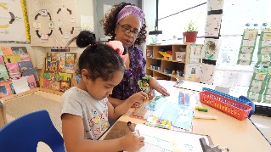 Trailer: https://vimeo.com/317575562
A Look at Quality Learning Environments

These videos are designed to support educators in creating quality learning environments for young children in Prekindergarten thru 2nd Grade classrooms. They illustrate how effective teachers can plan and implement a classroom design that supports children of all abilities and language backgrounds in their early learning stages of development.
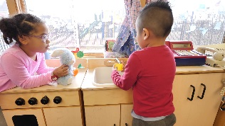 Prekindergarten: https://vimeo.com/310438802
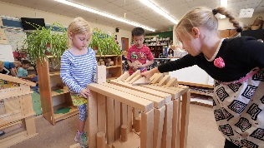 Kindergarten: https://vimeo.com/318076773
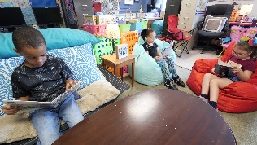 1st and 2nd Grade: https://vimeo.com/339169689
The Instructional Cycle: Standards, Curriculum, Instruction, and Assessment
These videos are designed to support educators in creating quality Prekindergarten thru 2nd Grade curriculum, instruction, and assessment that supports young learners of all abilities and language backgrounds and includes them as active participants in their learning. It is critical that teacher and administrators acknowledge that learning in Pre- Kindergarten to 2nd Grade is playful, interdisciplinary and connected to the standards. Strategies and effective practice will be reviewed within the context of standards, curriculum, instruction and assessment.
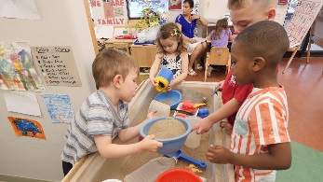 Prekindergarten: https://vimeo.com/310600457
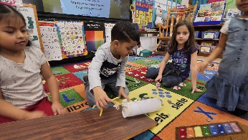 Kindergarten: https://vimeo.com/318065086
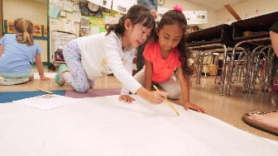 1st and 2nd Grade: https://vimeo.com/338082024

New York State Office of Early Learning
89 Washington Ave. Room 319 EB
Albany, N.Y. 12234
(518) 474-5807
OEL@NYSED.GOV

